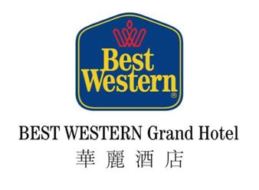

To ：Best Western Grand Hotel
Attention ：Irene Lo – Assistant Director of Sales - Corporate
E-mail ：adoscorp@bestwesterngrandhotel.com
Tel / Fax Number ：(852) 3122 6183 / (852) 2730 9936
Subject ：IWSSSCM3 2016 ( January 7 – 8, 2016 )
Dear Sir,
BEST WESTERN Grand Hotel is pleased to offer a Super-Save Rate at HK$880 for single/double occupancy per room per night under Superior room category & HK$50 per person per meal of buffet breakfast for those guests who join the captioned conference held by The Hong Kong Polytechnic University for coming January 2016. For reservation, please fill in the reservation form as below and return to us for confirmation.

* FREE in-room Wi-Fi internet service
* Above rates are applicable from Jan 5 – 8, 2016 inclusive
* All above rates are subject to 10% service charge
* Kindly make the reservation on or before 4 December, 2015. All reservations are subject to room availability and
hotel’s written confirmation.
===============================================================================
To be completed by accommodation application Date: ___________________
{ } Reservation { } Adjustment { } Cancellation

Guest Name(s) : _________________________________________________________________________

Arrival Date : __________________________________ Arrival Flight __________________________

Departure Date : __________________________________ Departure Flight ________________________

No. of room (s) : __________ Breakfast (s) ______ ( pax ) Special Request(s) _____________________

Room Type : Double-Bedded Twin-Bedded Smoking Room Non-smoking Room

Credit card Number : ___________________________________________________________________

Card Holder Name : ________________________________ Expiry Date (MM/YY): _____________
(For Guarantee Purpose ) ** Cancellation only accepted 7 days prior to arrival, otherwise one night room
rental will be charged as penalty **

Name of Application : ________________________________ Signature: __________________________

E-mail : ___________________________________Fax : ______________________________

Contact No. : _____________________________________________________________________
23 Austin Avenue, Tsim Sha Tsui, Kowloon, Hong Kong
香港九龍尖沙咀柯士甸路23號
Tel 電話: (852) 3122 6222 Fax 傳真: (852) 2730 9936
Website 網址 : http://www.bestwesterngrandhotel.com

THE WORLD’S LARGEST HOTEL CHAIN®

